**Vibe Lift Daily Testing**

**Home Page**

1. Add a footer section with the below links:

**Menu Legals Socials**

Home FAQs (X & Instagram icons)

About Terms and Conditions

Contact Privac y Policy

How it Works

1. Use the attached Privacy Policy document.
2. Use the attached Terms and Conditions document.
3. The Contact form section Privacy Policy and Terms and Conditions links to point to their footer documents.
4. When a user sends a contact form message, it should be sent to [info@vibeliftdaily.com](mailto:info@vibeliftdaily.com).
5. Add a captcha or something to the contact form to ensure human is sending the message and not phishing or spam.
6. Change the “Faqs” button in the header banner to “FAQs”.
7. The “FAQs” button to take the user to the ‘Frequently Asked Questions’ section of the page.
8. Change “Start trial” to “Start Trial”
9. Add a “Subscribe” button before “Start Trial” that takes the user to the same form.
10. Remove the “#” character from URL links (see below). (When we make navigation to go on different sections of same page. It needs that #)

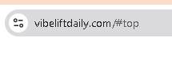

1. Use the Vibe Lift Daily logo n the browser tab (see below).



1. Replace these numbers with a ‘How It Works’ section (see below). We can add some numbers when the website has many users.

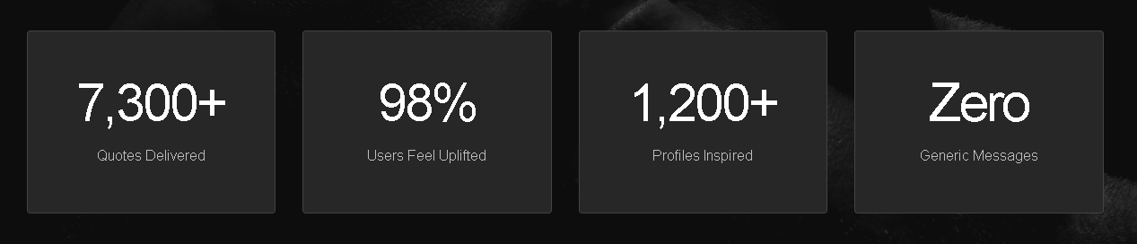

**Login**

1. Change “Join Vibe Lift Daily” to “Login to Vibe Lift Daily” (see below).

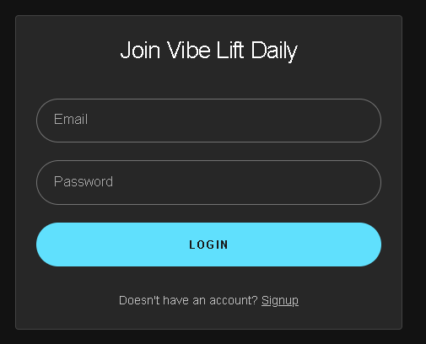

1. Add a ‘Forgotten password’ function.
2. When logged in change “Interests” to “Interests (comma separated)”

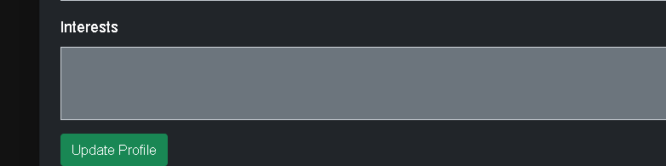

**Start Trial**

1. Change “Alloy (Female)” to “Female” and change “Onlyx (Male)” to “Male”.

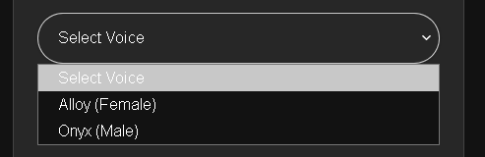

1. Indicate the mandatory fields with an asterix so the user knows which ones are mandatory. The mandatory fields are:

Name

Email

Select Voice

Password

Confirm Password

1. When a user signs up for a trial, they should receive a Welcome email, it should include their below statement from their account.



1. When a user signs up for a trial, a notification email should be sent to [alerts@vibeliftdaily.com](mailto:alerts@vibeliftdaily.com).

**Subscribe**

1. Why is PayPal only coming soon? Do you need my PayPal account to receive subscriber payments? This is in progress; we need to check if PayPal allows recurring payments with Laravel (framework we’re using). Until now I just found that they allow this in Node.JS.
2. I have subscribed from the UK at £9.99. What is the pricing model set up for other countries? They are converted to user’s currency.
3. What is ‘Pay with Link’? (see below).

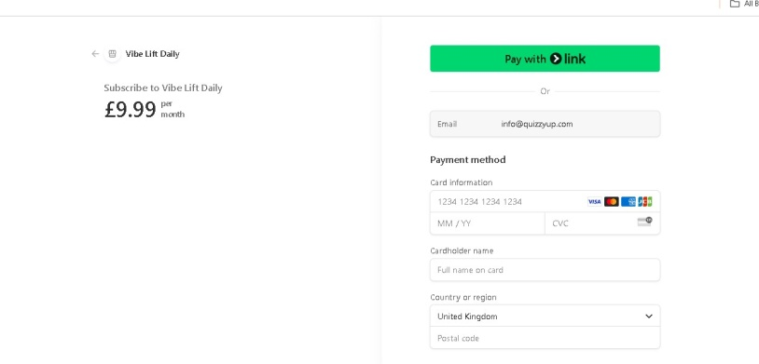

1. Does the payment function’s postcode/zip code field accept any country’s code format?
2. The payment function’s ‘Terms’ and ‘Privacy Policy’ links are to use the documents provided.  
   This page is shown up by stripe. Pay with LINK is their partner where users can save up their payment methods etc. We have no control on this page This is for Point 3,4,5.
3. What happens if a subscriber’s payment isn’t successful? It will show the error page.